**IBM Cloud Registration**

**Team Lead:** PRAKALYA E

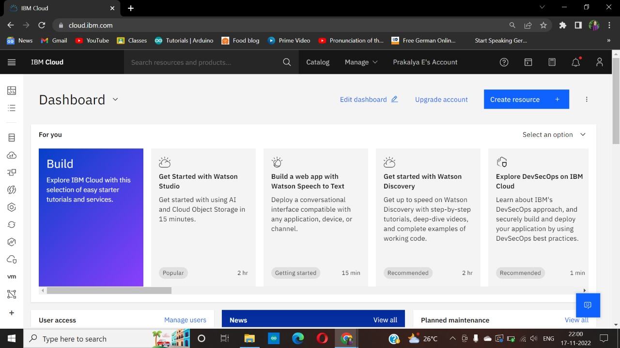

**Team Member 1:** ASWATHI R

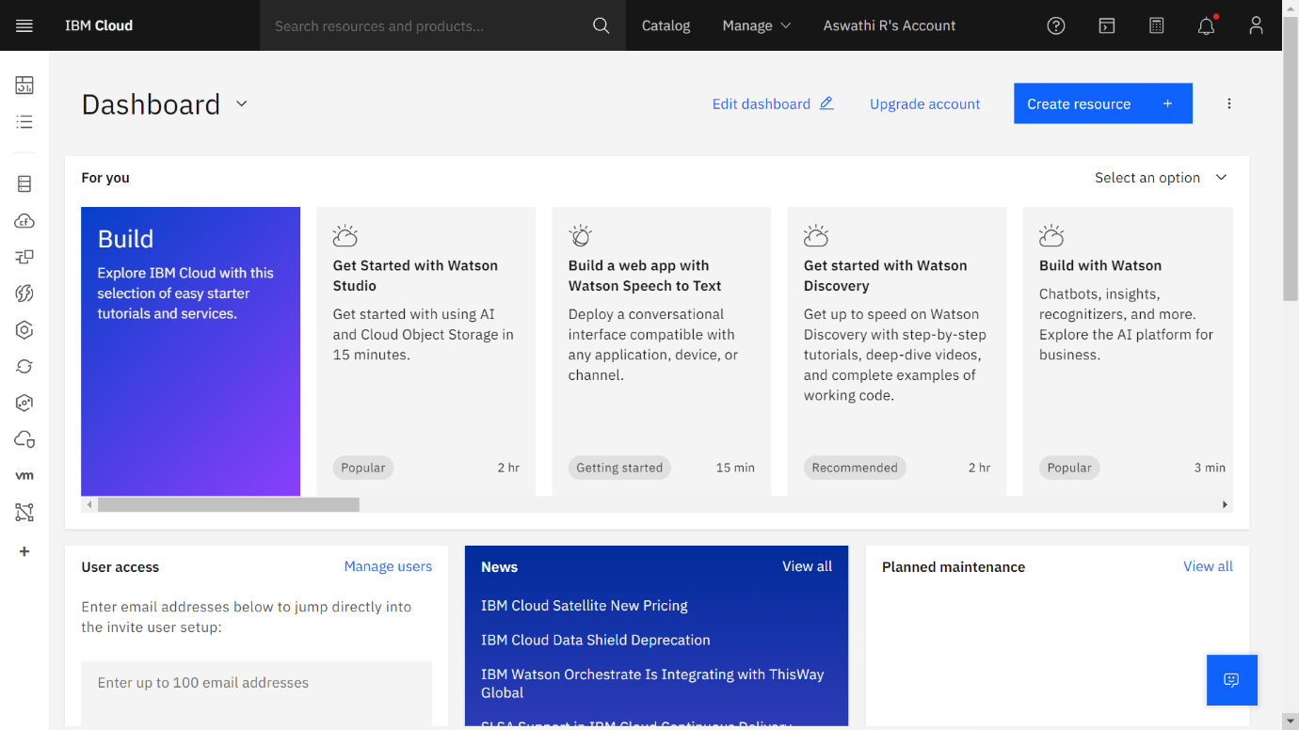

**Team Member 2:** SHAKTHI K

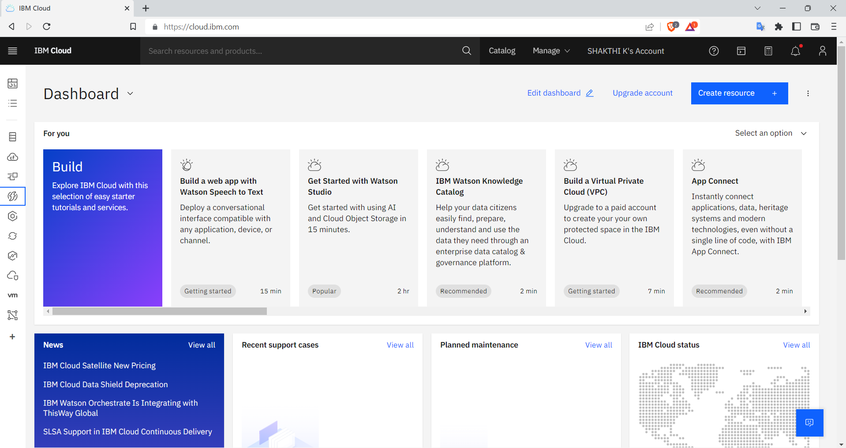

**Team Member 3:** YAZHINI KANNAN

